
Company
Logotype

Cone Beam Computed Tomography- Report



Porur Dental X-rays & CBCT

Patient Name : Miss. Vedha | Date of Report : 28.02.2025
Age/ Gender : 32 years/ Female | Region of Interest : CBCT Sectional Mandible
Referring doctor: Dr. Selva Ganesh | Indication : Assessment of 47
Clinical Notes: Nil
PATIENT INFORMATION

CBCT- Sectional Mandible provided
CBCT – IMAGE DETAILS

RADIOGRAPHIC INTERPRETATION

- In relation to 47, the crown of the tooth is present with areas of hypodensity, and the mesi0 buccal, mesio lingual and distal root canals are evident. However, in the sagittal section, there appears to be a hypodense discontinuity evident along the apical third of the root- at 5.02 mm from the interdental region of 46, 47 which appears to extend from the anterior surface of the root upto the posterior surface of the root.
- On viewing 47 in the cross- sectional plane, there is evidence of a linear hyperdense foreign body measuring 4.5 mm at the apical third of the distal root- distal root canal extending partially out from the apical foramen.
- The inferior alveolar canal is at a distance of 3.36 mm from the apical portion of 47.
- In 46, presence of hyperdense restorative material involving the crown distally is evident.

RADIOGRAPHIC IMPRESSION

- Incompletely root canal treated tooth: 47 with a retained periapical foreign body.
- Restored tooth: 46

Kindly correlate with clinical findings


IMAGES FOR REFERENCE

RECONSTRUCTED PANORAMIC VIEW

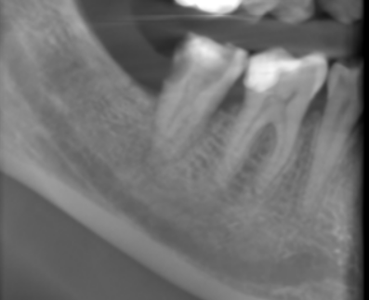

3-DIMENSIONAL VIEW

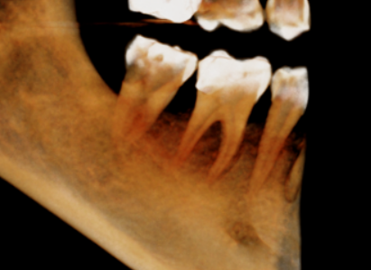

SAGITTAL VIEW | 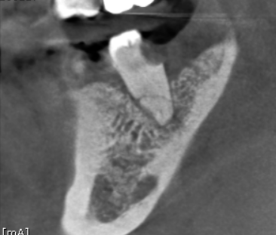  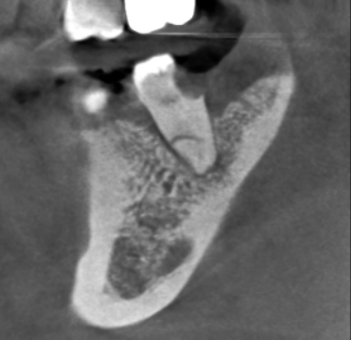  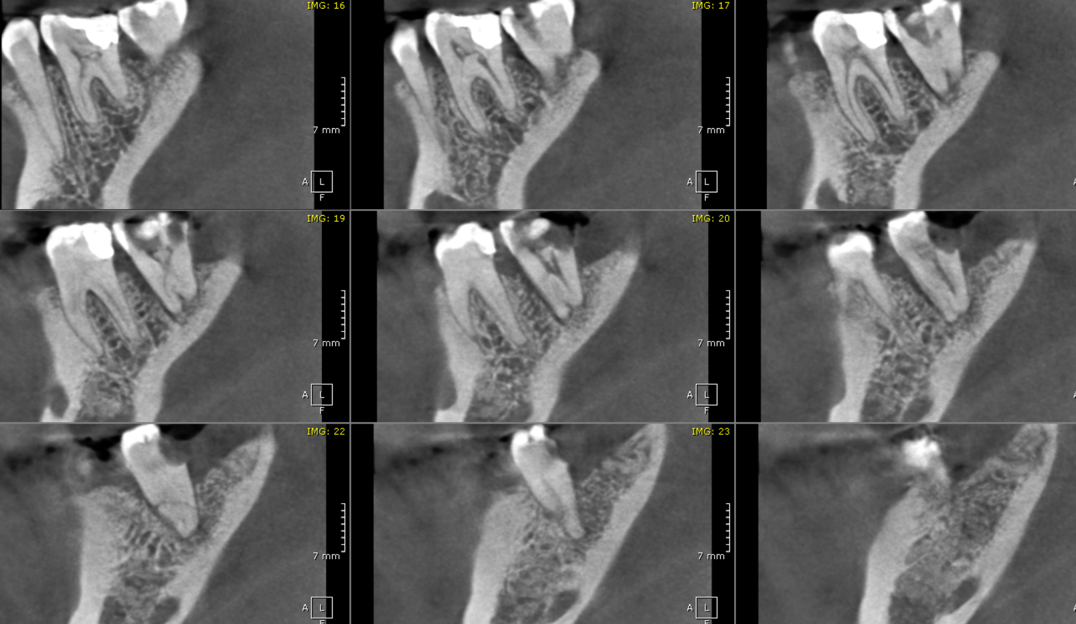
CORONAL VIEW | 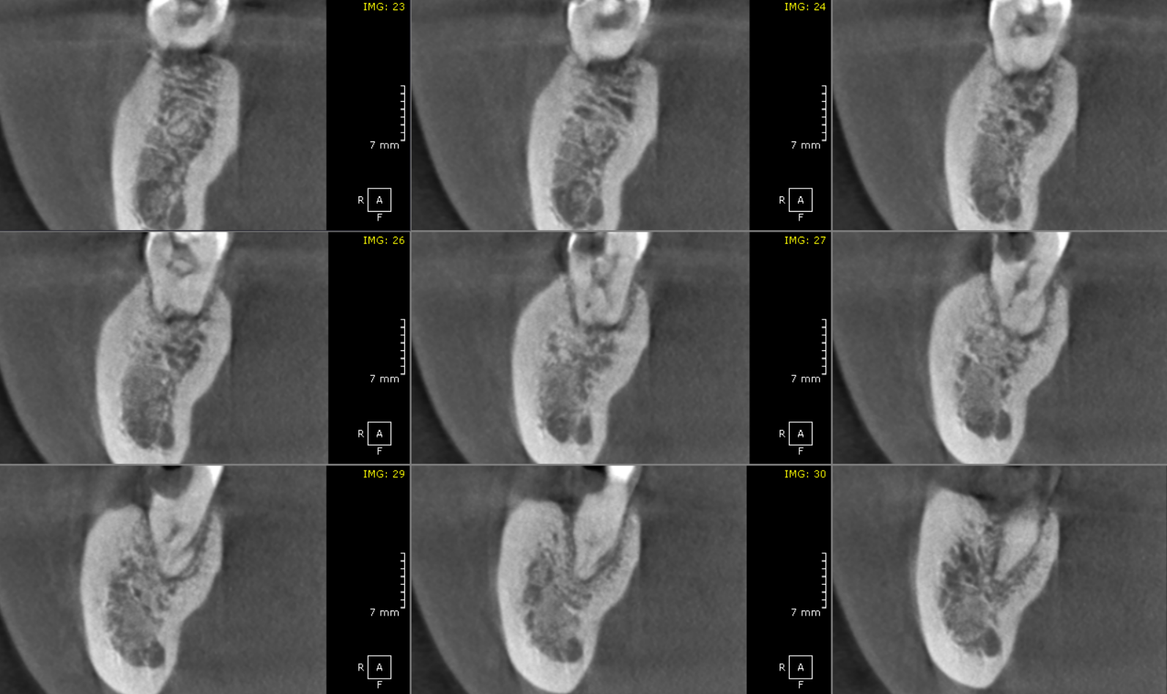
AXIAL VIEW | 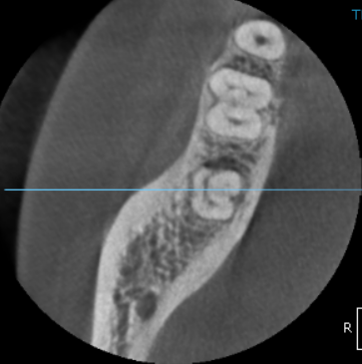
CROSS SECTIONAL VIEW | 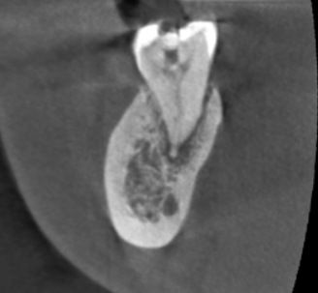

**** End of report ****

